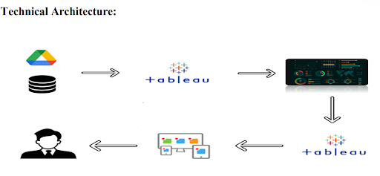

**🏗️ Technical Architecture: Heritage Treasures Project**

This architecture diagram explains how data flows from the source to the end-user using **Tableau**:

**📥 1. Data Source (Google Drive / Cloud / CSV / Database)**

* The data is stored on a **cloud-based platform** like **Google Drive**, or it can be a **local database / CSV file**.
* This dataset contains information about UNESCO World Heritage Sites (e.g., site name, country, danger status, region, inscription date, etc.).

**🔗 2. Tableau (Data Connection & Processing)**

* **Tableau Desktop or Tableau Public** is used to connect with the data source.
* It imports, cleans, and processes the data for visualization.

**📊 3. Interactive Dashboard**

* A visually rich **dashboard** is created using Tableau.
* It includes charts like **Treemaps, Pie Charts, and Line Charts** to analyze:
  + Sites per country
  + Sites at risk
  + Regional trends over time

**🌐 4. Tableau Server / Tableau Public (Publishing)**

* The dashboard is **published online** using **Tableau Public** or **Tableau Server**.
* This makes the report accessible across devices and browsers.

**👤 5. End User (Stakeholders / Public / Researchers)**

* The end-users (e.g., cultural researchers, NGOs, policymakers) can **view and interact** with the dashboard.
* They gain insights and make decisions based on the visualized data.

**🔁 6. Feedback Loop**

* Users may provide **feedback or new requirements**, which can result in updates to the data or dashboard.
* Tableau allows easy **modification and republishing** based on updated insights.

**🔄 Flow Summary:**

1. **Data Source** →
2. **Tableau (Data Connection)** →
3. **Dashboard Creation** →
4. **Publishing (Tableau Server/Public)** →
5. **User Access and Interaction** →
6. **Feedback for Updates**